Table of Contents
1 Classifier Features 2
2 Detailed Classifier Features 3
3- Logical Schema for Classifiers Features: Data Model – ERD and ETS 5
4- Tuple of the classifier Features Warehouse (Classifier Input) 11
5 References 12

1 Classifier Features
Features needed for the email classifier (Automatic Categorization of emails into folders) | Features
 | Email | Receiver | Attachment
 | Email ID [7] | Domain of receiver [1] [9] | Attachment type [1] [9]
 | Body Length [1] [9] | Number of CC [1] [9] | Has an attachment [1] [9]
 | Content Type [7] | Number of receivers [1] [9] | Number of attachments [1] [9]
 | Domain of sender [1] [9] | Number of To [1] [9]
 | Email Date [3] [7] | Receiver Username [1] [9]
 | Email Sender [1] [2] [7] [9]
 | Email Signature [9]
 | Email Subject [1] [2] [9]
 | Is Bcc [1] [2] [9]
 | Is distribution List [1] [9]
 | Language [1] [9]
 | MIME Version [7]
 | Number of punctuation Letters [1] [9]
 | Percentage of capital letters [1] [9]
 | Sender Username [1] [9]
 | Subject Length [1] [9]
 | Wordgram Frequency [1] [2] [9]
Table 1: Classifier Vs. Features

2 Detailed Classifier Features

Category | Feature | Description | Values | Source (preparation)
Email | Email ID [7] | Identifier for the email message | Long | System maintained primary key
Email | Domain of sender [1] [9] | Mail Service Provider (gmail.com, hotmail.com, ..etc) | String | Obtained from the sender's email, by taking the substring after the '@' character
Email | Language [1] [9] | Dominant language in the email body | String | Use a special module to detect the language type of the email body
Email | Email Sender [1] [2] [7] [9] | Email address of the sender | String | Obtained directly from the email header
Email | Content Type [7] | Content type | String | Obtained directly from the email header
Email | Email Date [3] [7] | Date of sending the email represented as the number of milliseconds since January 1, 1970, 00:00:00 GMT | Long | The date is obtained directly from the email header and then transformed to the long representation
Email | MIME Version [7] | MIME is an internet standard to extend the format of the email to support non-ASCII data | Integer | Obtained directly from the email header
Email | Bcc [1] [2] [9] | List of email receivers as Bcc | Each recipient is represented as a boolean attribute in the feature tuple. | Obtained directly from the email header
Email | Number of punctuation Letters [1] [9] | Number of punctuation characters in the body | Integer | Count the number of punctuation letters in the email body
Email | Is distribution List [1] [9] | Flag to indicate whether the client received this email from a group/distribution list or not | Boolean | Obtained directly from email header
Email | Email Signature [9] | Signature of the email sender, at the end of the email | String | The signature is extracted from email body
Email | Wordgram Frequency [1] [2] [9] | Email Wordgram Frequency | Integer | Count the number of wordgrams in the email
Email | Subject Length [1] [9] | Length of the email subject | Integer | Calculate the size of the subject string
Email | Percentage of capital letters [1] [9] | Percentage of the capital letters to the letters in the email body | Double | Count the number of capital letters and divide it by the sum of the sizes of all ASCII words in the email body
Email | Body Length [1] [9] | Size of the email body | Integer | Calculate the size of the body string
Email | Sender Username [1] [9] | Name of Sender | String | Obtained directly from email header
Email | Total Number of words | Number of words in the email body | Integer | Calculate the number of words in the email body
Email | Email Subject [1] [2] [9] | Subject of the email | String | Obtained directly from the email header
Receiver | Receiver Username [1] [9] | Name of receiver | String | Obtained directly from email header
Receiver | Number of receivers [1] [9] | Number of email receivers | Integer | Count the number of receivers obtained from email header
Receiver | Number of CC [1] [9] | Number of CC recipients | Integer | Count the number of CC recipients obtained from email header
Receiver | Number of To [1] [9] | Number of CC | Integer | Count the number of receivers mentioned in the TO header
Receiver | Domain of receiver [1] [9] | Mail Service Provider(s) for the receiver(s) | String | Obtained directly from email header
Attachment | Number of attachments [1] [9] | Number of attached files in the email | Integer | Count the number of attachments obtained from the IMAP interface
Attachment | Attachment type [1] [9] | Type of attachment | String | The type of the attached file is extracted from attachment informations
Attachment | Has an attachment [1] [9] | Flag to denote whether the email has an attachment | Boolean | If the number of attachment is zero, return false, else return true

3 Logical Schema for Classifiers Features: Data Model – ERD and ETS

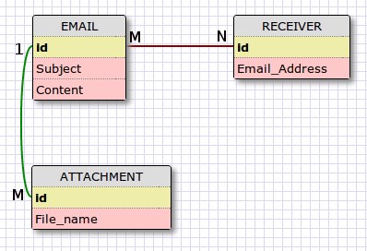Illustration 1: Classifier Data Model

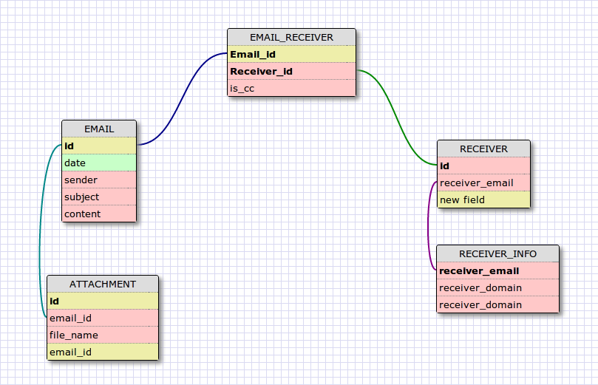Illustration 2: Classifier Entity Relationship Diagram

Project: Smart Email | Subject: Classifier Features | Page: 1/1
Entity: Email | Date: Thursday, March 1, 2012 | Analyst:
Attribute | Type | Size | Validation / desc
Id | Integer | 4 Bytes | Primary Key, system maintained, used to identify different emails
date | Date | - | the date the email was received in
sender | String | 40 Characters | The email address of the email sender
subject | String | 40 Characters | The Subject of the email
content | Text | - | The body of the email

Project: Smart Email | Subject: Classifier Features | Page: 1/1
Entity: ATTACHMENT | Date: Thursday, March 1, 2012 | Analyst:
Attribute | Type | Size | Validation / desc
Id | Integer | 4 Bytes | Primary Key, system maintained, used to identify different attachments
email_id | Integer | 4 Bytes | Foreign key to EMAIL.id
file_name | String | 40 Characters | Name of the attachment

Project: Smart Email | Subject: Classifier Features | Page: 1/1
Entity: RECEIVER | Date: Thursday, March 1, 2012 | Analyst:
Attribute | Type | Size | Validation / desc
Id | Integer | 4 Bytes | Primary Key, system maintained, used to identify different recipients
receiver_email | String | 40 Characters | Email of the receiver
receiver_name | String | 40 Characters | Name of the receiver
receiver_domain | String | 40 Characters | Domain of the receiver
Project: Smart Email | Subject: Classifier Features | Page: 1/1
Entity: EMAIL_RECEIVER | Date: Thursday, March 1, 2012 | Analyst:
Attribute | Type | Size | Validation / desc
email_id | Integer | 4 Bytes | Composite Primary Key, system maintained, used to identify different email/receiver tuple
receiver_id | Integer | 4 Byte
is_cc | Boolean | 1 Byte | Used to indicate whether this receiver is mentioned in cc header or not

4 Tuple of the classifier Features Warehouse (Classifier Input)

email_id
date
sender_email
sender_username
Domain of sender
is_bbc
subject
Subject_length
content
content_mime_version
body_length
signature
number_of_receivers
Percentage_of_capital_letters
Number_of_punctuation_letters
language
has_attachments
number_of_attachments

Project: Smart Email | Subject: Classifier Features | Page: 1/2
Entity: Feature_tuple | Date: Thursday, March 1, 2012 | Analyst:
Attribute | Type | Size | Validation / desc
Id | Integer | 4 Bytes | Primary Key, system maintained, used to identify different feature_tuples
email_id | Integer | 4 Bytes | Foreign key to EMAIL.Id
date | Date | - | Date of sending the email in the long representation
sender_email | String | 40 Characters | Email of the sender
sender_user_name | String | 40 Characters | Name of the sender as it appears in the contacts list
domain_of_sender | String | 40 Characters | Email Service Provider for the sender
is_bcc | Boolean | 1 Byte | Indicates whether the user received this email as a recipient or as a Bcc recipient
subject | String | 40 Characters | The Subject of the email
subject_length | Integer | 4 Bytes | Length of the email subject
content | Text | - | Email body
content_type | String | 40 Characters | Content type of the email
content_mime_version | Integer | 4 Bytes | MIME version of the email
body_length | Integer | 4 Bytes | Length of the email body
signature | String | 512 Characters | Sender's signature at the end of the email message
number_of_attachments | Integer | 4 Bytes | Number of attachments in the email
Project: Smart Email | Subject: Classifier Features | Page: 2/2
Entity: Feature_tuple | Date: Thursday, March 1, 2012 | Analyst:
Attribute | Type | Size | Validation / desc
number_of_receivers | Integer | 4 Bytes | Number of email recipients
percentage_of_capital_letters | Double | 8 Bytes | Percentage of capital letters in the email body
number_of_punctuation | Integer | 4 Bytes | Number of punctuation letters in the email body
language | String | 40 Characters | Dominant language of the email body
has_attachments | Boolean | 1 Byte | True if the email has attachments, false otherwise

5 References
[1] JM Carmona-Cejudo, M Baena-Garcia, Feature extraction for multi-label learning in the domain of email classification, 2011
[2] R Bekkerman, Automatic categorization of email into folders, 2004
[3] S Kiritchenko, S Matwin, Email classification with temporal features, 2004
[4] G Forman, An extensive empirical study of feature selection metrics for text classification, 2003
[5] YF Yi, CH Li, Email Classification Using Semantic Feature Space, 2008
[6] Y Yang, A comparative study on feature selection in text categorization, 1997
[7] Anatomy of an email message, http://www.rickconner.net/spamweb/anatomy.html
[8] SQL designer http://code.google.com/p/wwwsqldesigner/
[9] JM Carmona-Cejudo, M Baena-García, Gnusmail: Open framework for on-line email classification

